Math 252 -- Calculus II -- Lab 3

Names:________________________________

_________________________________

_________________________________

_________________________________

Labs are best if done in your group, during lab time.
Late labs will be penalized 20%, and will only be accepted up to one week late.
Any group lab turned in by an individual will be penalized 10%.

Rules:

Work together:
Everyone works on the same problem at the same time.
Everyone agrees on the solution before you move on.
Remember that you are practicing your mathematical
communication skills!

Turn in one paper per group. Make sure that the paper you turn in is clean, clear, and organized.

Part 1: Practice Integration by Substitution

Evaluate the integral by making the given substitution, then check by taking the derivative of your answer. Show your work clearly and correctly!

- 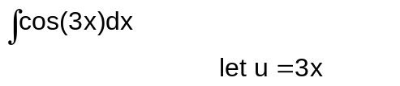 check:

- 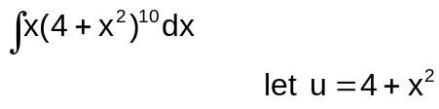 check:

- 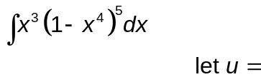 check:

Part 2: A ball is thrown from the top of a 224 foot tall building with an initial velocity of 80 ft/sec. Can we find an equation for the path of the ball as a function of time? Yes, we certainly can, now that we know how to do anti-derivatives.
Acceleration due to gravity near the surface of the Earth is 32 ft/sec². Since this force acts downward, we think of it as negative 32 ft/sec².
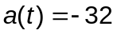
- Find the anti-derivative of the acceleration function to find the velocity function. Remember that the initial velocity is 80 ft/sec, so when t=0, your function should equal +80. Include units.
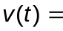

- Find the anti-derivative of the velocity function to find the position function. Remember that the initial height is 224 ft (that's how tall the building is), so when t=0, your function should equal 224. Include units.
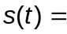

- On the graph paper below, carefully graph and label the position function and the velocity function on the same set of axes.

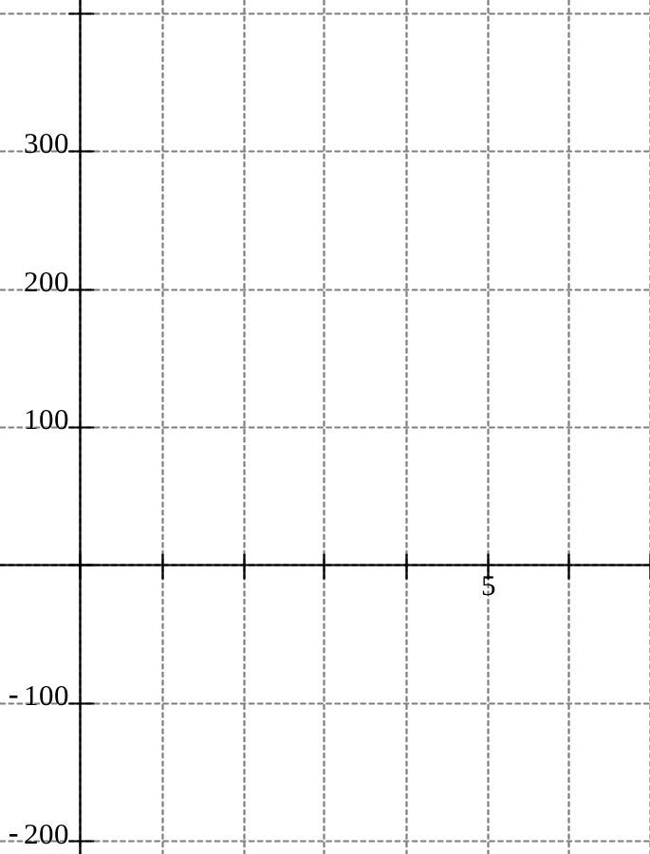
What do you notice at t = 2.5 on both functions?
The ball has reached its _________, and the velocity is ______.
What do you notice about the functions on the interval 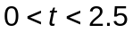?
The ball is moving _________, and the velocity is ______.
What do you notice about the functions on the interval 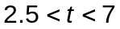?
The ball is moving _________, and the velocity is ______.

Part 3: Clearing the Hill
(Stewart, Instructor's Manual, 4e)

The late actor Jimmy Stewart drove a very old car. In fact, when he drove it up a certain hill on Route 66 (near the giant dinosaur) it would decelerate until it hit the top, and then accelerate down the hill until he could barely control it. It usually took him a full 3.25 minutes to go from the bottom of the hill on one side to the bottom of the hill on the other.
When he told this story, he would usually specify that after driving one minute, his speed was 0.4 miles/minute. If we take the time he started up the hill as t = 0, then one model for his acceleration in miles/minute² is given by
a(t) = t - 1.5, where t is in minutes. Notice that this model is only valid for his time on the hill. We make no claim for its validity before the start of the climb (t=0 minutes) or after the finish time (t=3.25 minutes).

- Find a formula for his velocity at time t. Include units.

- Find a formula for the distance traveled at time t. Include units.

- What was his starting velocity in miles per hour?

- What was his final velocity in miles per hour?

- What was his minimum velocity in miles per hour?

- When did he reach the top of the hill?

- How far did he travel from start to finish?

- You may have noticed that Stewart was speeding when he approached the hill. Under normal circumstances, he would have been loath to break the laws of his state. But he knew that if he started at 65 miles per hour, he would not have made it to the other side. What would have happened, and how do you know?

- When Jimmy told this story on the Tonight Show, he exaggerated about how big the hill was. He told the host that it took him six minutes to traverse it. The host quickly determined he was not telling the truth. Assuming that the acceleration model [ a(t) = t - 1.5 ] was still accurate, and assuming that Jimmy Fallon knew some calculus, how did he see through Jimmy Stewart's story?

